## **Second Progress Report**

Alina Jakiyeva, Sabrina Zholamanova SE-2004

Current functionality

1. **Log in and Log out**

The first and most basic functionality is logging in and out of the application. That is, all students will be entered into the database and everyone will have their own specific login and password to log in, where they can then change their password when logging in if they want. Also log out of the system, more precisely from the application.

1. **Edit profile**

Administrators can change their profile data, as well as student data, such as attributes such as phone number, mail, and so on. All these changes will be located in the profile and the profile of the student or administrator will be updated immediately.

1. **Add news**

Administrators can add news for students about current events. They can write a name, a description about each event. News is necessary for updating data in the students' home, that is, notifying each of them about upcoming events or inspections.

1. **Complaint Form**

Students through their profile can leave various positive and negative comments about certain events that occurred in the dormitory. For example, if a student is not satisfied with something in the accommodation, in the neighbors, and so on, he can safely leave a complaint, which will then be considered by the university staff.

1. **Room management**

Administrators can display a whole list of rooms, dormitories and apartments. That is, there are 3 dormitories in our university. Firstly, they will be able to open a list of three dormitories. Then, after choosing a dormitory, they can choose the apartment number they need, then a room. And each room will be provided with a list of students who live in it. You can also open the entire list of students, where one of the parameters will describe their data on living in rooms.

1. **Deleting students**

If a student left the students' home, was expelled, or for any other reason collected documents and left the dormitory, then in this case administrators can delete his profile from the database.

**ERD diagram.**

Our diagram is a complex of interrelated attributes or entities that make up the whole system. The center of this ERD diagram is a dormitory. Which takes the data of the employee who is responsible for this hostel, that is, the commandants. There will also be employees who generally manage the management department of the students' home.The essence of an employee consists of his personal data, these attributes you can see in the table. Each of the employees can publish upcoming news, for this purpose there is a News entity in our diagram, which consists of a description, title and publication date. Further, each dormitory has apartments and rooms that are interconnected and belong to each other. Each of these entities consists of attributes relevant to it, such as the number of rooms, apartment number, room number, and so on. And the last essence of our diagram is students. It includes all personal data about them, first and last name, phone number, and so on. With the help of foreign keys, we will indicate which of the dormitories, apartments and rooms the students belong to.

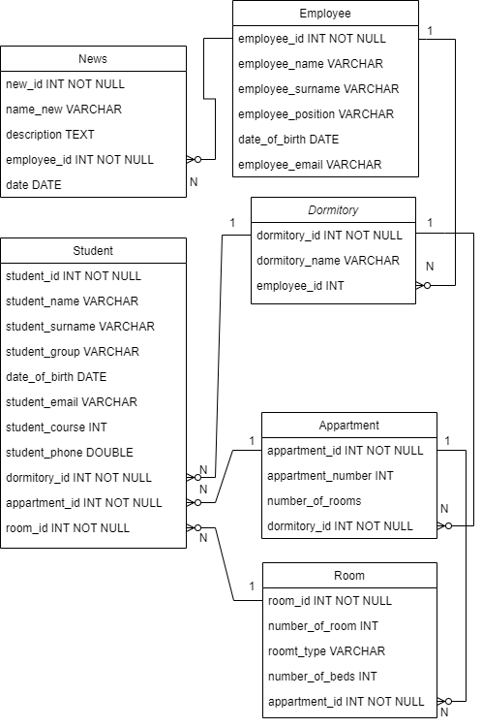

DFD Diagram

Next is the data flow diagram of our project which mapped out the main processes in the system, such as sign in, DB manipulation, student data alteration and interacting with complaint forms. The dormitory admin may add students, then allocate the rooms to them which would alter the DB information. They can update information regarding the students, and additionally update the room information.

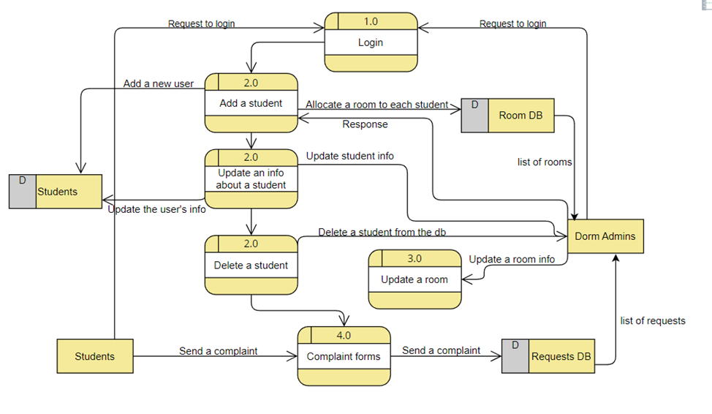

UML Diagram (Use Case)

Next is the use case of our project which showcases the main activities happening in the system, the sub-activities and perpetrators. Users may create an account with the given university mail, which would further include such functions like logging and editing their own profile. The user may as well view and browse the news, send complaint forms, use QR code as a verification before entering the dormitory. Whereas the admin has the access to the DB containing requested complaints, rooms and their state, students-residents and news.

